Restore AKS from backup to a new AKS or existing AKS

1. Create the new AKS

NOTE- it must be in same region where the backup vault is. IF WE WANT TO RESTORE TO ANOTHER REGION, THEN THE CROSS REGION RESTORE SHOULD BE ENABLED.

Aks 🡪 Storage account 🡪 backup vault 🡪 restore point aks (all must be in same region)

1. Install backup extension to the targeted AKS where we do want to restore.

Note- We need to use storage account for this operation. Storage account and the use blob container Must be in any region. But it can be in any Resource Group.

Note- If we did not follow this process before and directly went to restore from backup vault restore point. We will get option here to configure too.

1. Navigate to Backup Vault and select backup instance on which we stored backup (particular cluster or namespace we want to restore).

Or

We can go for Backup vault overview and select to restore it will navigate us to select instance restore point we want to restore and also primary region restore or secondery region restore.

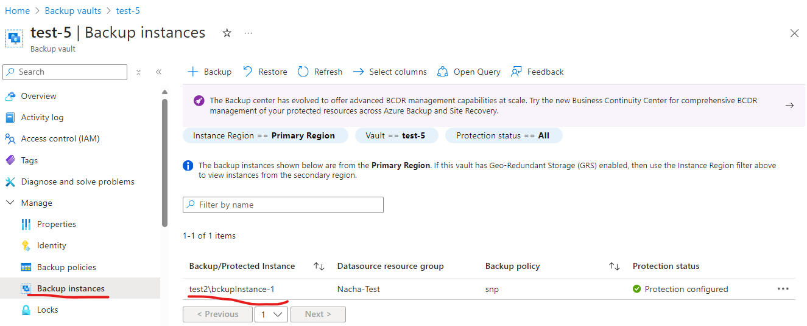

Select restore point to restore.

1. Select restore parameter such as Target cluster to restore.

IF the roles are missing, assign missing roles and grant permissions.

Once it’s done move to next step.

Go for restore configuration select the resource to restore. Namespace api etc..

Also we can choose backed up namespace to a target namespace

Also here the snapshot resource group and storage account take place, but we don’t need to do anything manually.

Go for review and restore.

If not validated, go back and validate and then finally restore.

Triggering restore may take some time and once restore done login to aks and do validation that everything restored properly.

Connect to aks.

